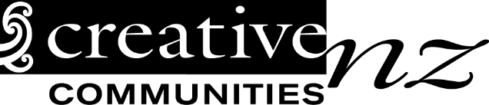
Project Completion Report
This Project Completion Report form must be submitted within two months after your project has been completed.
Please note that if you don’t complete and return a satisfactory report you or your group will not be eligible for future Creative Communities Scheme funding.
Name of applicant:
Project name:
Start date: |  | Finish date:
Number of people who actively participated in your project?
Number of people who came to see a performance or showing of your project?
- Give a brief description of the highlights of your project:
What worked well? What didn’t work? What might you do differently next time? Are there any future plans for this project? If you require more space please attach additional pages.

- How did your project deliver to the criteria that you selected: Participation and access, diversity or young people? If you require more information about these criteria please refer to the CCS Application Guide.
- Financial report: Please give details of how the money was spent.

Project costs
Write down all of your project costs. Include all items from the budget in your application.
Item  eg. Venue hire | Budgeted cost (from application)  eg $600 | Actual cost  eg $400 | Reason for difference in amounts (if any)  eg Project moved to cheaper venue
Total costs | $ | $
Project Income
Write down all of your project income. Include all items from your application budget. Include your Creative Communities Scheme grant.
Item  eg Ticket sales | Budgeted income (from application)  eg $1600 | Actual cost  eg $1700 | Reason for difference in amounts (if any)  eg Extra tickets sold
Creative Communities Scheme Grant | $ | $
Total income
Costs less income
You may be required to provide receipts for this project. Please keep your receipts in a safe place for seven years.

- Other material. Please attach copies of any of the following :
- A summary of participant or audience survey results
- Newspaper articles or reviews
- Responses from other people involved in the project
- Responses to the project from other funding bodies or partners/supporters
- Photos of the project and/or artwork
Do we have permission to use these photos to promote the Creative Communities Scheme? |  |  |  | Yes |  | No
Please return your Project Completion Report to:
Waitomo District Council
Queen Street, Te Kuiti 3910
info@waitomo.govt.nz

