Notice to Tenderer

NTT no: 03

Date: 28 March 2023
Contract Name: i-SITE & Railway Building 1 - Alterations, Renovations and New Fitouts
Contract No: 500/23/004
Number of pages (incl. cover):
Document No. 657868

Writer: Avanish Mudaliar

SUBJECT: Updated RFQ

Notice to Tenderer:

- This is to confirm that the closing Time for the ‘Submission of Quotation’ for this contract work has been extended further to 4.00 p.m.

Updated CLOSING DATE AND TIME: Quotation close at 4.00p.m. NZT on 29 March 2023.

Quotations are to be submitted in the Tender Box located at:
15 Queen Street,
Te Kuiti.
No later than by 4:00 pm on Wednesday 29 March 2023.

Electronic quotes are not acceptable and will not be evaluated.

If you have any queries, please do not hesitate to contact the undersigned.
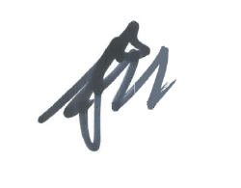
Paul Moller
Programme Lead - Procurement

