RURAL TRAVEL FUND
GUIDELINES FOR JULY 2021 – JUNE 2024

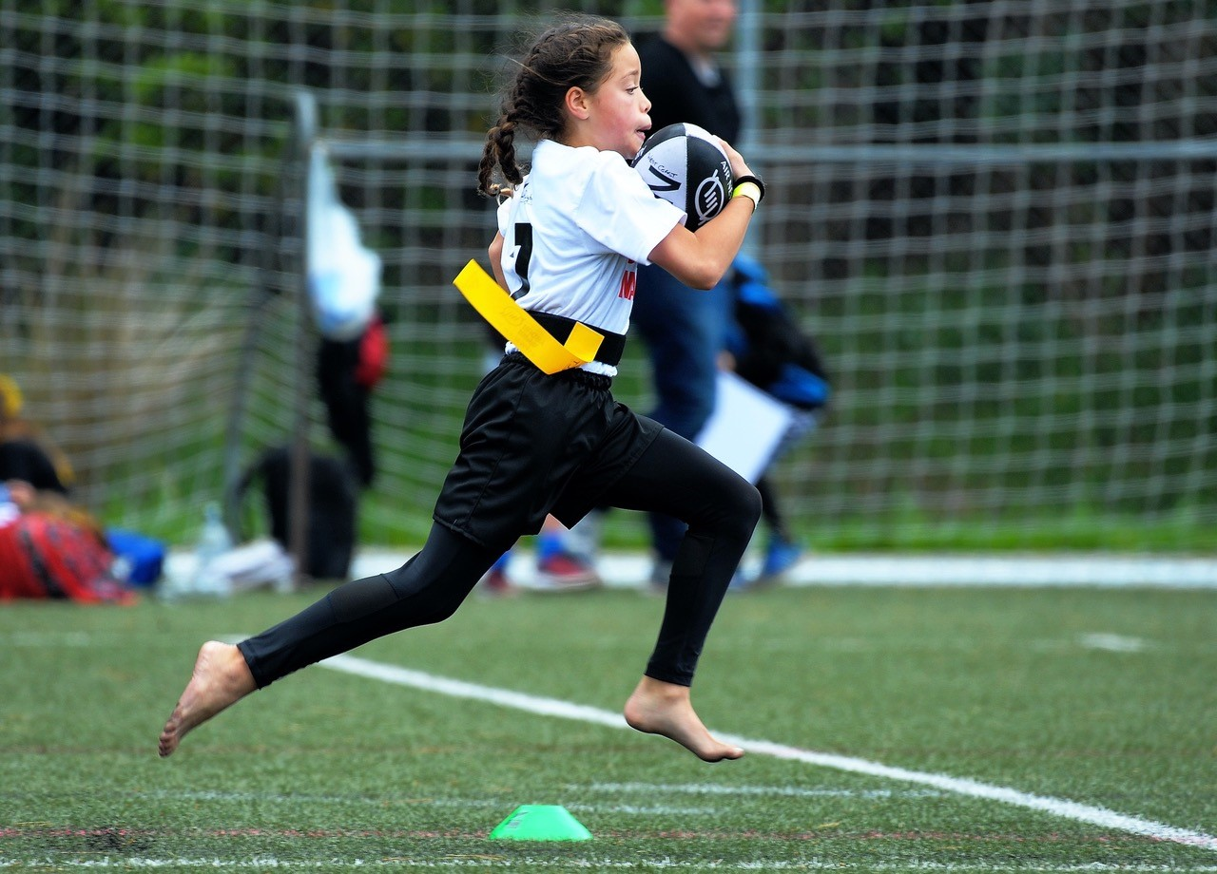

CONTENTS OF GUIDELINES

Guidelines
1) | Background | page 3
2) | The Fund Detail | page 3
3) | Sport NZ Strategic Direction | page 3
4) | Amended Rural Travel Fund Application Form | page 3
5) | Sport NZ Other Funding Streams | page 4
Information for Applicants
6) | Eligible teams | page 5
7) | Eligible travel | page 5
8) | Accountability for funding | page 5
11) | Goods and services tax (GST) | page 6
12) | Return of unspent funding | page 6
13) | Further information | page 6
Frequently asked Questions
14) | FAQs | page 7

GUIDELINES

Background

The Sport NZ Rural Travel Fund (RTF) was established in 2003 with the purpose being to “remove the barrier of cost to participation for those in rural communities”. In 2020-21 the RTF was allocated across 35 ‘provincial’ TAs in Aotearoa.

The Fund - Detail

The Rural Travel Fund (RTF) will be administered on Sport NZ’s behalf by thirty-five eligible Territorial Authorities (TAs) across Aotearoa. These guidelines apply for the period to 30 June 2024.

The RTF is to provide quality sport opportunities and experiences for tamariki (children aged 5-11) and rangatahi (young people aged 12-18). We would ask that the TAs receiving RTF consider how they place an emphasis on providing sport experiences for:

- Girls and young women aged 5-18; and/or
- Disabled tamariki (5-11) and rangatahi (12-18)

In 2021-24 Sport NZ will allocate $444k to the 35 eligible TAs for distribution into their communities.

- Sport New Zealand Strategic Direction 2020-2032

In mapping our strategic direction to 2032, Sport New Zealand have introduced a new vision and purpose.

Our Purpose
To contribute to the wellbeing of everybody in Aotearoa New Zealand by leading an enriching and inspiring Play, Active Recreation and Sport system

Our Vision
Every Body Active

- Amended Rural Travel Fund Application Form

As we are interested in understanding more about how this fund is currently being used within your community, we adjusted the RTF application form template to seek more data from applicants on gender and disability. Please ensure that you use this updated form going forward.

- Other Sport New Zealand Funding Streams

Sport NZ also offer other community funding opportunities such Tū Manawa Active Aotearoa. If you are interested in knowing more, we suggest that you follow Sport NZ and your local Regional Sports Trust on social media (or sign up to their newsletter) to be kept informed.

INFORMATION FOR APPLICANTS

- Eligible teams

Applications for funding from the Rural Travel Fund can be made by rural sport club teams and rural school club teams within the Territorial Authority region, with members aged between 5 and 18 years, who require financial assistance with transport costs so that they can participate in local sporting competitions and events.

- Eligible travel

The following criteria will be applied by Territorial Authorities when considering applications for funding made by eligible teams (along with any other criteria that the Authority considers appropriate).

A rural school club team will be eligible for funding if it is participating in a regular local sports competition out of school time, which excludes inter- school and intra-school competitions run during school time.

A rural sports club team will be eligible for funding if it is participating in an organised, regular sports competition through club membership outside of school time.

Please note: Funding will not be provided for, and may not be used for, the purpose of travel to regional or national sports competition.

Accountability for funding

You must only use the funding for travel costs that arise from the team participating in a local competition, and as agreed with the relevant Territorial Authority.

You must return an accountability form to the Territorial Authority administering your funding that shows how the funding was spent, including by providing proof of purchases made and any receipts.

Goods and Services Tax (GST)

GST registered organisations:
If you are a GST registered organisation, the Territorial Authority administering your funding will pay your funding plus GST. You must then account for the GST to the Inland Revenue Department (IRD).

Non-registered GST organisations:
If you are not GST registered, the Territorial Authority administering your funding will not add GST to your funding.

Return of unspent funds

You must return any funds you have not spent as of 30 June 2022 to the Territorial Authority administering your funding.

Further information

If you have any questions regarding the Rural Travel Fund, there are FAQs at the back of these Guidelines. Sport New Zealand also has a FAQ section on its website at Rural Travel Fund | Sport New Zealand - Ihi Aotearoa (sportnz.org.nz).

If you would like to speak to someone in person, please contact Fiona Ramsay at Sport New Zealand on 021 535 714 or email fiona.ramsay@sportnz.org.nz

FAQs

Q | What is the Sport NZ Rural Travel Fund?
A | The Sport NZ Rural Travel Fund is a partnership between Sport New Zealand and Territorial Authorities to subsidise travel costs for young people that live in rural communities to attend sporting competitions and events..
Q | Who administers this funding?
A | Territorial Authorities administers the Rural Travel Fund on behalf of Sport New Zealand.
Q | Can individuals apply for funding?
A | No, all applications must come from rural sport club teams or rural school teams. Funding will not be provided to individual players, coaches, or officials.
Q | How are Territorial Authorities selected to participate in the Rural Travel Fund?
A | Sport New Zealand has selected Territorial Authorities based on a formula that takes into account population density. Eligible Territorial Authorities have a population density of less than 10 people per square kilometre.
Q | Where can I get an application form?
A | Application forms can be obtained from your local Territorial Authority.
Q | Who do I contact if I have any questions about the application form or eligibility for funding?
A | Contact your local Territorial Authority as they administer this fund on behalf of Sport New Zealand.
Q | Who can apply for funding?
A | Sport club teams and school club teams within a Territorial Authority that receives Rural Travel Funding, who have members aged between 5 and 18 years, and who meet the Rural Travel Fund eligibility criteria.
Q | Our team has applied for funding to help pay for travel expenses to get to National Champs. Are we eligible?
A | No, you are not. Funding is only available for travel to regular, local competition. For example, Saturday morning or weeknight games.
Q | Can we get funding for our school team for a one off or annual inter school competition?
A | No, funding is only available for travel to regular , local competition
Q | How can I find out able the application process for the Rural Travel Fund?
A | Contact your local Territorial Authority for more information.
Q | Who should I contact at Sport New Zealand for more information?
A | Please contact Fiona Ramsay at Sport New Zealand on 021 535 714 or email fiona.ramsay@sportnz.org.nz
Q | Which Territorial Authorities are eligible for Rural Travel Funding?
A | - Ashburton District Council  - Buller District Council  - Carterton District Council  - Central Hawkes Bay District Council  - Central Otago District Council  - Chatham Islands Territory  - Clutha District Council  - Far North District Council  - Gisborne District Council  - Gore District Council  - Grey District Council  - Hurunui District Council  - Kaikōura District Council  - Kaipara District Council  - Mackenzie District Council  - Marlborough District Council  - Ōpōtiki District Council  - Ōtorohanga District Council  - Queenstown-Lakes District Council  - Rangitikei District Council  - Ruapehu District Council  - Selwyn District Council  - South Taranaki District Council  - South Wairarapa District Council  - Southland District Council  - Stratford District Council  - Tararua District Council  - Tasman District Council  - Taupō District Council  - Waimate District Council  - Wairoa District Council  - Waitaki District Council  - Waitomo District Council  - Westland District Council  - Whakatāne District Council

